

Elicitation Plan

Campus Wellness Portal with Medical System and Fitness Center Integration

Version: 1.0

Date: 23/05/2025

Release By: TT6L - Group 3

**Development Framework:**

For this project, we are using the **Kano model** to classify potential requirements into three categories:

* Dissatisfier (must-be requirement): Basic features that users expect. Their presence does not significantly increase satisfaction, but leads to dissatisfaction of the customer if they are missing.
* Satisfier (one-dimensional customer requirement): Features where more functionality leads to more satisfaction. If these are missing, the satisfaction of users will be slightly reduced.
* Delighter (attractive requirement): Unexpected features that delight users when present but do not cause dissatisfaction when absent.

We chose the Kano model for the following reasons:

* To decide which requirements should be elaborated next
* To focus the elicitation activities on one class of customer satisfaction
* To establish a good balance of system features between the different classes of customer satisfaction

**Elicitation Techniques:**

During our group discussion, we were initially torn between using a questionnaire, observation or brainstorming for elicitation. After careful consideration, we decided to proceed with the questionnaire as the primary elicitation techniques for collecting inputs from users and categorize their requirements using the Kano model, and held a brainstorming session among our group members to help identify and define system requirements before executing the questionnaire.

*Table 1.1 Elicitation Techniques*

| Technique | Reason for Selection | Plan for Execution |
| --- | --- | --- |
| Brainstorming | * Efficient in identifying requirement sources * Efficient in developing innovative requirements * Encourage diverse perspectives | * Conduct Microsoft Teams meeting for estimated 2 hours on 8.00pm at 29th April 2025 * Involve all group members * Brainstorming covers the requirements for each stakeholder * Each requirement is finalized only after group agreement * Requirements are recorded using Visual Paradigm and LucidChart |
| Questionnaire | * Efficient in identifying requirement sources * Efficient in eliciting existing requirements * Ensure data accuracy * Flexibility * Time and cost saving | * Create and design two questionnaires, one for functional requirements and one for quality requirements using Google Forms * Each of them consists of 16 single choice questions, cover both functional and dysfunctional perspectives * Distribute the forms to university students across Malaysia via various social media platforms such as WhatsApp, WeChat and Facebook Messenger from 8th May 2025 to 16th May 2025 * Target to receive at least 20 valid responses from 20 respondents for each questionnaire * Categorize the requirements using Kano Model based on the result obtained from questionnaires |

**Potential Requirements Classification:**

We classified the potential requirements based on our assumptions before executing the actual elicitations, using two key dimensions: user satisfaction and functionality. The following are the table and Kano Model chart.

*Table 1.2 Classification of requirements*

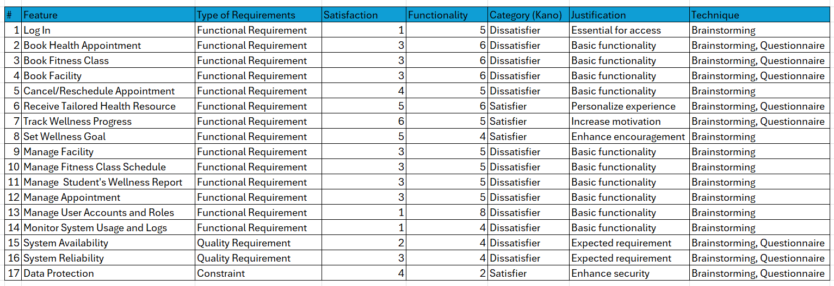

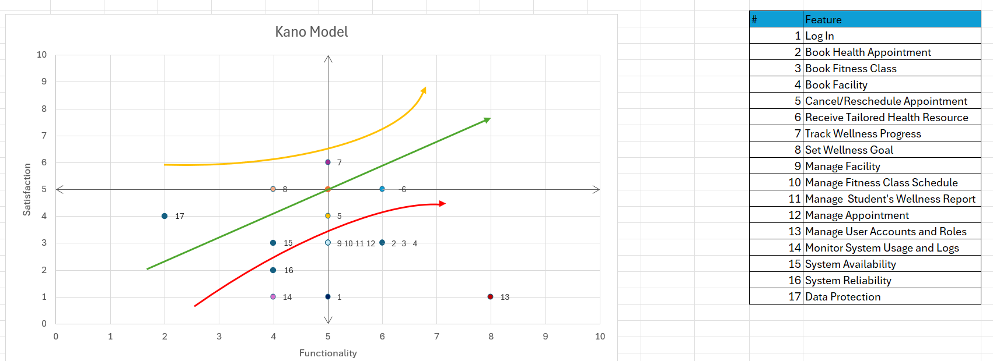

*Figure 1.1 Kano model*

The finalized requirements and their classification using the Kano Model will be documented in the Task 4 Kano Model report after all elicitation activities have been completed.